# CS 255 System Design Document Template

This template lays out all the different sections that you need to complete for Project Two. Each section has guidance to prompt your thinking. You will need to continually reference the interview transcript as you work to make sure that you are addressing your client’s needs. There is no required length for the final document. Instead the goal is to complete each section based on what your client’s needs are. Remove this note when you are finished, and replace all bracketed text with the relevant information.

## UML Diagrams

### UML Use Case Diagram

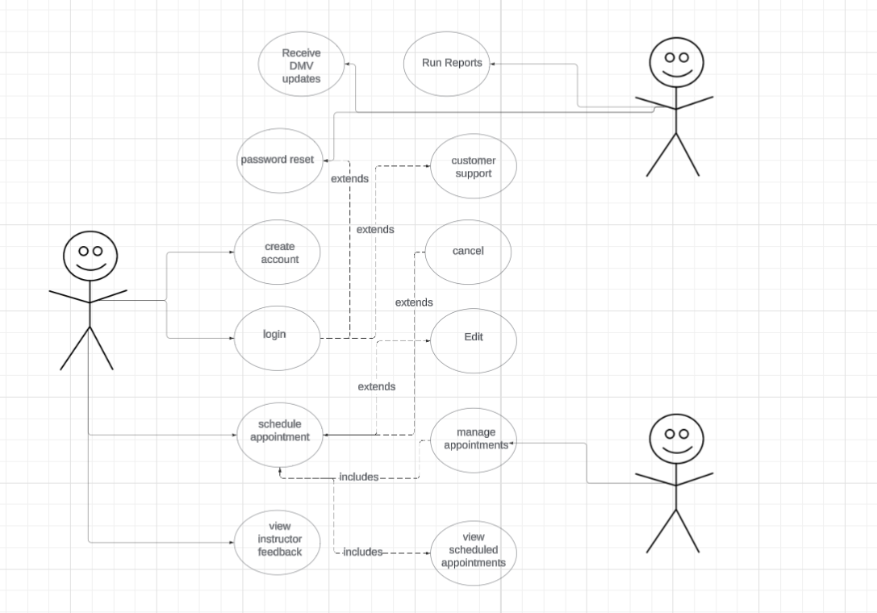

### UML Activity Diagrams

*Create account:*

Schedule appointment:

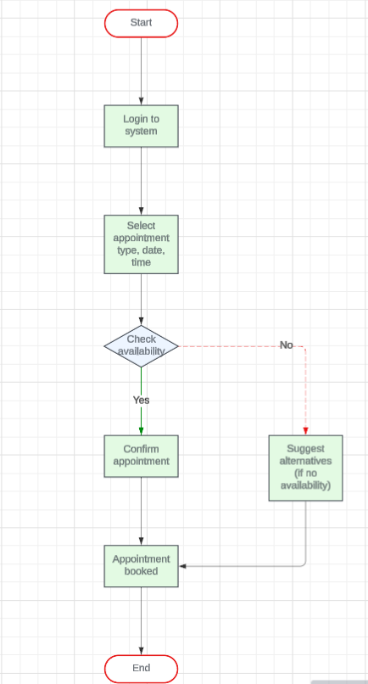

### UML Sequence Diagram

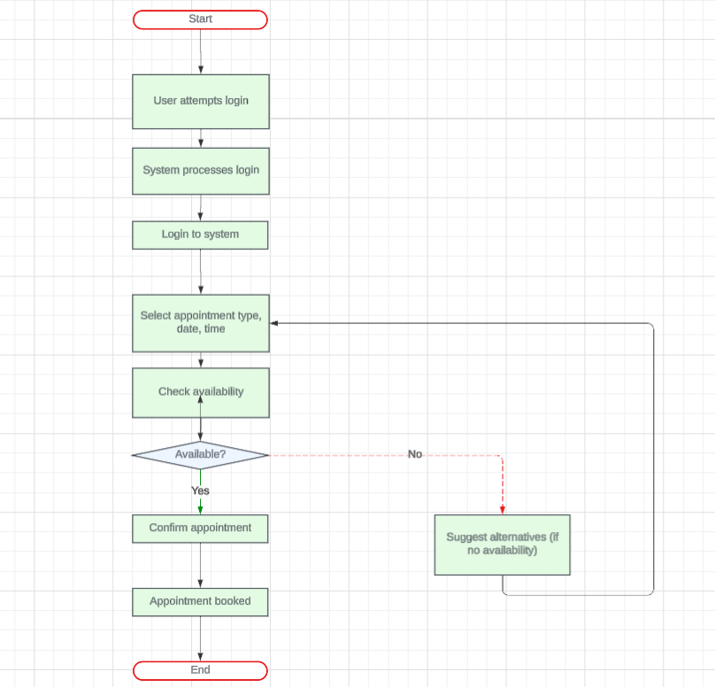

### UML Class Diagram

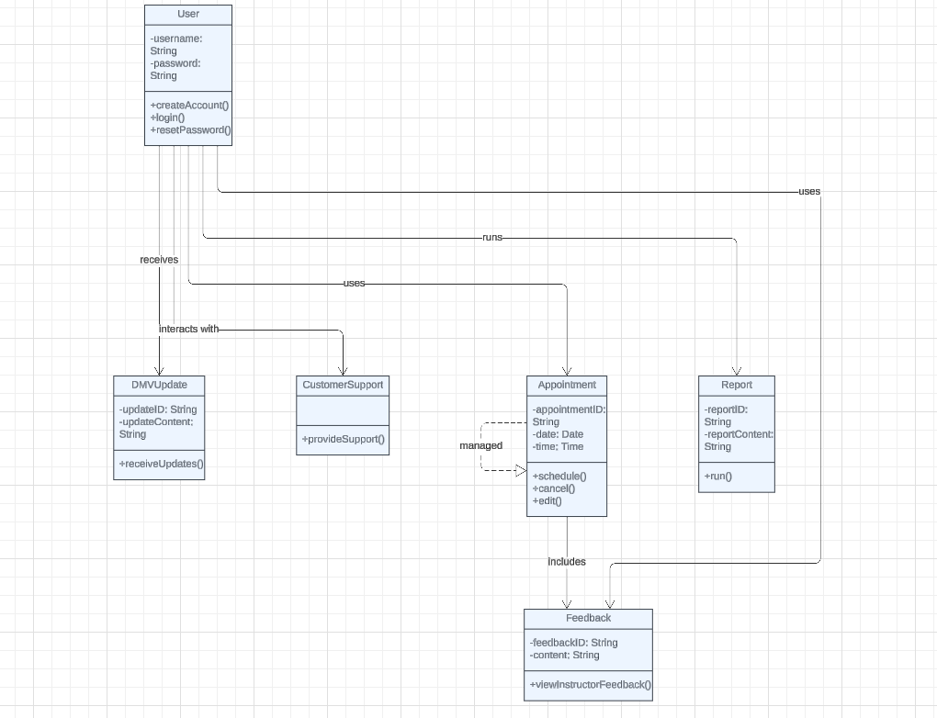

## Technical Requirements

*The system needs a strong and flexible setup, both in terms of hardware and software. On the hardware side, it requires a reliable server with enough processing power, memory, and storage to handle its workload, along with devices like computers, tablets, or smartphones for users to access it. For software, it needs a stable operating system (like Windows Server or Linux) to run everything smoothly, a web server (such as Apache or Nginx) to handle online requests, and a database (like MySQL or MongoDB) to store and manage information. The system also relies on programming tools for building both the backend and frontend, using languages like Java, Python, or frameworks like React. Security is key, so protections like SSL/TLS encryption and firewalls help keep data safe. To make development and maintenance easier, tools for coding, version control, automated testing, and deployment (such as CI/CD pipelines) are essential. Finally, a strong internet connection and optional cloud services (like AWS or Azure) can help the system run smoothly and scale as needed.*